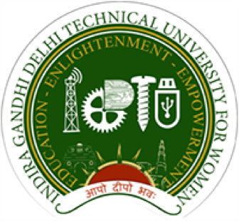

INDIRA GANDHI DELHI TECHNICAL UNIVERSITY FOR WOMEN

(
Established by Govt. of Delhi vide Act 9 of 2012

Kashmere Gate, Delhi
-
110006

BEST PRACTICE 1: EDUCATION MENTORING PROGRAMME (EMP)

Motto: “Social Ambassadors for Knowledge Dissemination Programme & Hand holding Initiatives”
With the aim of supporting and guiding girls studying in Delhi government schools to take up flourishing careers in the STEM fields and also to foster a deeper understanding in IGDTUW students about how they can become the protagonists of positive change in society, the university has initiated the Education Mentoring Program. IGDTUW has partnered with the Government of Delhi to reach the school girls of Delhi with the aim of touching their lives in a positive way. The project's "Education Mentoring Programme" involves mentoring of girls studying in Delhi government schools by the B.Tech, M.Tech, B.Arch., B.BA, MBA, and PhD students of IGDTUW to raise their awareness of Science, Technology, Engineering, and Mathematics (STEM) education. Each IGDTUW mentor guides five girls studying in the 9–12 grade and help clear their doubts about careers in STEM, share strategies for clearing entrance exams, support in accessing learning resources, and motivate them as they transition out of their schools to pursue further education and careers. As many as 250 students of IGDTUW became mentors for more than 1,000 girls studying Science in Classes 11 and 12 in Delhi government schools.Further,the students also counselled students in grades 9 to 12 on the deep significance of harnessing their potential through a focus on education.
Implementation strategy:
The entire work of the project was monitored and executed through the PMU of IGDTUW. Given the outreach of the project, it was implemented in phase-wise in a structured manner. IGDTUW has a Project Management Unit (PMU) comprised of the core team, which was supported by identified and motivated Mentor Leaders (students of IGDTUW). In the pilot phase, almost 200 mentors (students of IGDTUW) worked under the PMU to guide almost 1000 girls in schools. Once the pilot phase is over, based on the learning, the project will be scaled up.
Initially, for the pilot phase, it is planned to initiate the process with 200 mentors (IGDTUW students) with a target of mentoring almost 1000 mentees (school students-girls). Measures was taken to upscale the project multifold and mentor almost 10,000–12, 000 mentees (school children) in the next 1 or 2 years. This will not only benefit schoolchildren but will also contribute to the development of an educated and gender-balanced future.
More Details: https://www.youtube.com/watch?v=Hq-umw7K4L4&t=3s
EMP Launch Video: EMP Launch Video Link
EMP Documentary Video: EMP Video Link
Recognition:
Delhi Deputy Chief Minister Manish Sisodia felicitated 250 students of Indira Gandhi Delhi Technical University for Women (IGDTUW) for providing guidance to over 1,000 girl students under the Delhi government's education mentoring programme.
Link to Newspaper coverage: https://drive.google.com/drive/folders/1_71aMr1tpjd3AIg1C6jobisd9hvEEY5x
Report in detail and newsletter available at: https://www.igdtuw.ac.in/studentlife.php?id=488
Other Supporting Documents : https://drive.google.com/drive/folders/1He2GoGZ3uHS-Zu-k41ystp5uVFlbmlkl

